Svea Payments Finland

Payment Module

for

Adobe Commerce (Magento)

*Module version 1.1.0*

**Table of Contents**

1 General information 3

2 Change history 3

3 System requirements 3

4 Installation 4

4.1 Install the payment module 4

4.2 Check the current version information 4

4.3 Upgrade the existing module 4

4.4 Remove the payment module 5

4.5 Migrate from previous generation Svea payments module 5

4.6 Possible conflicts with Svea_Maksuturva module 6

5 Configuration 7

5.1 Preferred Magento settings 7

5.2 Payment methods page 7

5.2.1 Collated payment methods 8

5.2.2 Separate payment methods 8

5.2.3 Redirect to Svea’s Payment Method Selection Page 9

5.3 Svea Payments Configuration 10

5.4 Svea Part Payment Calculator 12

5.5 Additional features 14

5.5.1 Payment Fees 14

5.5.2 Delayed capture 14

5.5.3 Automatic status query 15

6 Order administration 16

6.1 Refunding order 17

7 Logging 18

8 Resolving issues and support 18

8.1 Common problems and solutions 18

# General information

The module magento2_svea_payments enables Svea Payments’ payments on the Adobe Commerce (Magento) platform. This plugin supports all Svea Payments payment methods, including card, online banking, mobile payments, invoice, part payment and B2B invoice payment methods.

With the module, customers can select their desired payment method on the website checkout page or on the Svea website.

The delayed capture feature allows payments to be captured when the order processing is completed, and the package is sent to the customer.

To use this module in production, you need an activated Svea Payments payment service contract. Additionally, for testing purposes, you can order test credentials for the Svea Payments test environment. You can find more details in the Testing section at [Svea Payments API / TESTING](https://sveapayments.atlassian.net/wiki/spaces/DOCS/pages/1657014153/TESTING).

# Change history

Changelog: [Changelog.md](https://github.com/maksuturva/magento2_svea_payments/blob/main/CHANGELOG.md)

Release history: <https://github.com/maksuturva/magento2_svea_payments/releases>

# System requirements

|  |  |
| --- | --- |
| **Requirement** | **Supported versions** |
| Magento | 2.4.4 or newer |
| Composer | 2.0 or newer |
| PHP | 8.1 or newer |

There is no guarantee that the plugin is fully functional in any other environment.

# Installation

Installation requires basic knowledge of Magento Administration, Magento CLI and Composer. Update PHP and Magento to fulfill the system requirements.

To use the payment module, you need to install version 2 of the Composer package management tool. For more information, see [Composer (getcomposer.org)](https://getcomposer.org/doc/)

It is recommended that you update and back up your current installation to ensure optimal performance and data safety.

During installation, the module installs required database tables and adds cron jobs for payment status query background jobs.

*If you are migrating from previous generation Svea payment module (aka.* [*https://github.com/maksuturva/magento2_payment_module/*](https://github.com/maksuturva/magento2_payment_module/)*) and about to upgrade to this new module version, start from the section* *4.5 Migrate from previous generation Svea payments module* *first.*

## Install the payment module

Add payment module to Composer requirements.

composer require svea-payments-finland/magento2-svea-payments

Build and update Magento installation.

php bin/magento setup:upgrade

php bin/magento setup:di:compile

php bin/magento setup:static-content:deploy -f -j 3

php bin/magento cache:flush

Check that cron service is running.

service cron status

if needed, start cron as follows.

service cron start

## Check the current version information

By using the composer tool, you can easily check the current version of any installed payment module. This can be extremely helpful for ensuring that all your plugins are up-to-date and functioning properly.

composer show svea-payments-finland/magento2-svea-payments

## Upgrade the existing module

To upgrade the existing module version of this module to the latest version, you can utilize the composer update mechanism.

composer update svea-payments-finland/magento2-svea-payments

Build and update Magento installation.

php bin/magento setup:upgrade

php bin/magento setup:di:compile

php bin/magento setup:static-content:deploy -f -j 3

php bin/magento cache:flush

## Remove the payment module

To remove the payment module, use the following command.

composer remove svea-payments-finland/magento2-svea-payments

Please note that the database information must be cleaned manually. We don’t support automatic data removal currently.

## Migrate from previous generation Svea payments module

This section includes instructions to migrate from previous generation Svea payments module (<https://github.com/maksuturva/magento2_payment_module>).

Before making a production update, it would be advisable to test the update in an environment similar to production and verify the functionality throughout.

* Take a full database backup.
* For later review, export list of current orders at Magento Sales / Order page

1. Disable old payment module version.

php bin/magento module:disable Svea_Maksuturva Svea_MaksuturvaBase Svea_MaksuturvaCard Svea_MaksuturvaCollated Svea_MaksuturvaGeneric Svea_MaksuturvaInvoice Svea_MaksuturvaPartPayment Svea_OrderComment

1. Do module installation as described in section 4.1 Install the payment module and after installation continue here.
2. Migrate old config parameters to new module config parameters. Note! This will clear all settings in the current module configuration. Run

php bin/magento svea:migrate:config

1. After migrate config command, go to

Stores >> Configuration >> Svea Payments >> Svea Payments Configuration

As result, you should see configuration fields filled with correct values. For example, Seller ID field is not empty anymore.

1. Check configuration for correctness and *Save Config*.
2. Optional but recommended: migrate old orders to new module format. Orders placed with previous Svea_Maksuturva payment methods can be migrated via Command Line Interface (CLI).

Without migration, you cannot refund or make status queries for orders created with Svea_Maksuturva payment methods.

php bin/magento svea:migrate:sales --date *2023-01-01*

With the *--date* option, you can migrate orders starting from a specific date. Format *YYYY-MM-DD*. **Note!** Without the *--date* option, the command will migrate all orders.

1. Finally, go Payment Methods to check configured checkout payment methods.

## Possible conflicts with Svea_Maksuturva module

If you have enabled Svea_Maksuturva module, the php bin/magento setup:upgrade step of installation will inform you if you need to disable Svea_Maksuturva module.

After that you need to repeat the php bin/magento setup:upgrade step to continue with the installation process.

# Configuration

You can find settings related to payment module in:

* Stores / Configuration / Svea Payments / Svea Payments Configuration
* Stores / Configuration / Svea Payments / Svea Part Payment Calculator
* Stores / Configuration / Sales / Payment Methods
* Stores / Configuration / Sales / Sales / Order Comment

Testing instructions: [Svea Payments API / TESTING](https://sveapayments.atlassian.net/wiki/spaces/DOCS/pages/1657014153/TESTING)

## Preferred Magento settings

Make sure the store currency is set to EURO *Stores >> Configuration >> General >> Currency Setup >> Base Currency*

Use default country as *Finland,* *Stores >> Configurations >> General >>> General >> Default Country* – recommended.

**New in 1.1.0**

Orders work according to Magento payment flow and are set to *Pending Payment* when checking out. These orders, if left unpaid, will be cancelled automatically by Magento after their lifetime expires. This lifetime can be configured in

*Stores >> Configuration >> Sales >> Sales >> Orders Cron Settings >> Pending Payment Order Lifetime (minutes)*

Default value is 480 which is 8 hours.

Before version 1.1.0, orders were set to state *Pending* when checking out. These orders are never automatically cancelled by Magento. If needed, this can be done manually in

*TODO >> TODO*

## Payment methods page

Go to *Stores / Configuration / Sales / Payment Methods*. Press *Configure* to select active Svea payment methods.

On the checkout page, you have three options to choose from for how the payment methods should appear. These options are:

1. Collated Payment Methods - This option groups Svea payment methods together, and you can customize various settings. This is the recommended option.
2. Separate Payment Methods - This option activates individual Svea payment methods.
3. Redirect to the Svea Selection Page - With this option, the payment method redirects to the Svea website for the final payment method selection.

### Collated payment methods

Ensure that the Enabled option is set to Yes in the Common section. This section contains the main title that appears on the checkout page for payment options in Magento.

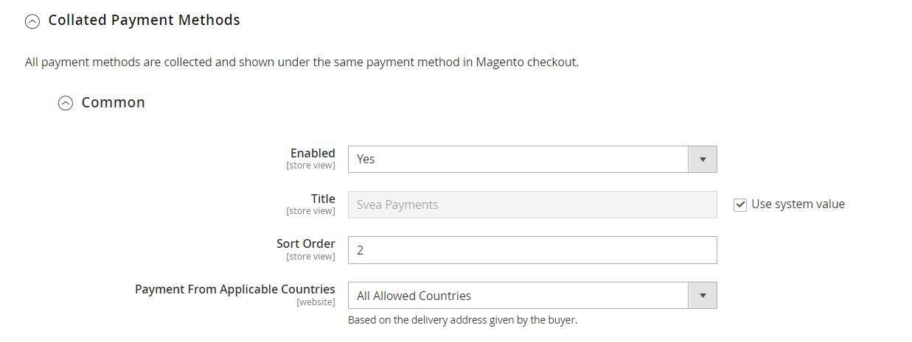

Under the Common section, there are six subgroups of Payment methods that come with default titles. These subgroups offer various payment methods that sellers can choose from. You are free to customize the title of each subgroup and select the payment methods that you want to make available.

If you wish, you can also set a default invoicing fee for all payment methods. Alternatively, you can set the fee individually for each payment method by adding the details in the table view provided. The invoicing fee will be added to the payment amount.

Remember to click Save Config after configuration changes and flush Magento cache.

Example of collated payment methods on Checkout page

### Separate payment methods

If you want payment methods to be shown at the checkout under payment method groups that can be opened in radio buttons, you can choose Separate Payment Methods at the configuration page as an alternative to Collated Payment Methods.

Enable the selected payment method groups and add payment methods under each group or use the default system setting. You can change the header of the payment method group and select the order of the payment method groups to be shown at the checkout.

Example of the separate payment methods on checkout page:

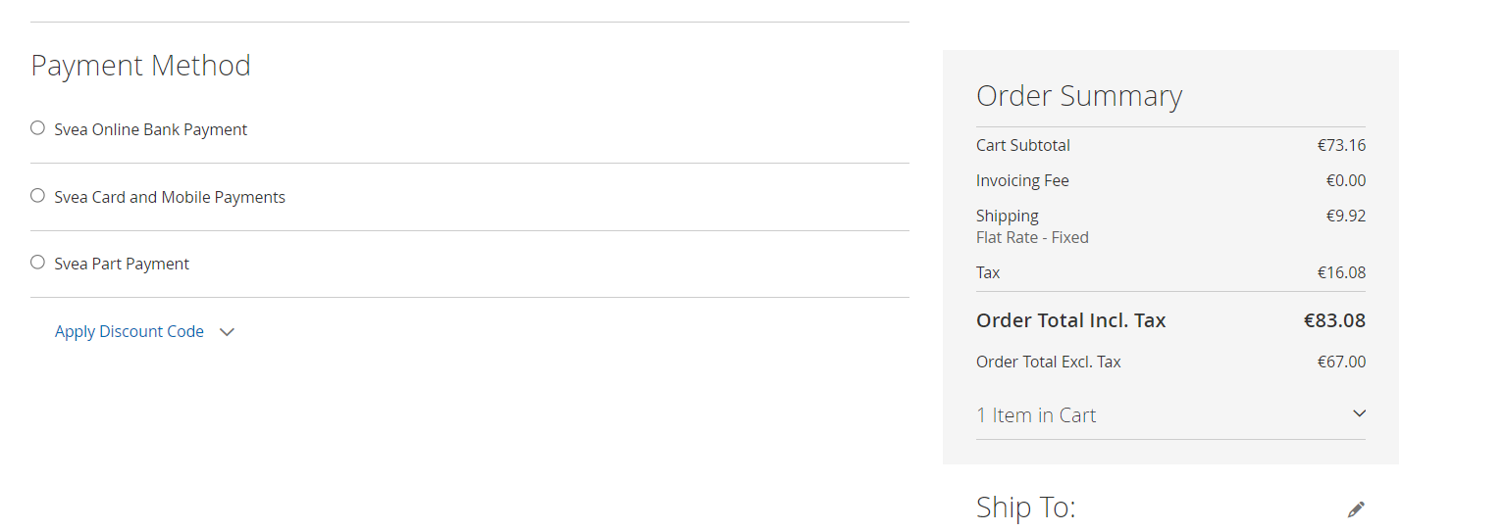

### Redirect to Svea’s Payment Method Selection Page

If you want the payment methods to be selected at Svea’s payment method selection page instead of showing the payment methods directly at the checkout, you can enable only this payment method in the configuration. You don’t need to choose or activate any individual payment methods, since all payment options you have with Svea will appear automatically.

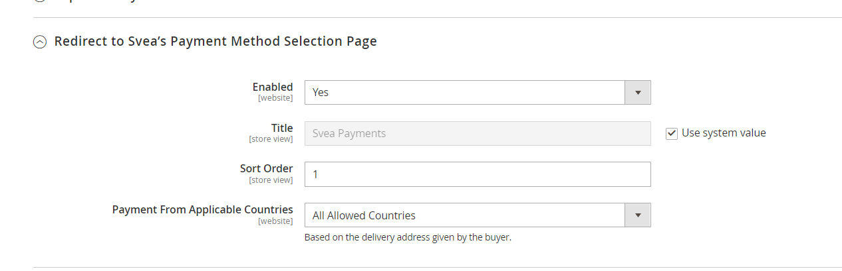

From the checkout the buyer will be redirected to Svea’s page to choose the payment method.

Example of Svea’s payment method selection page:

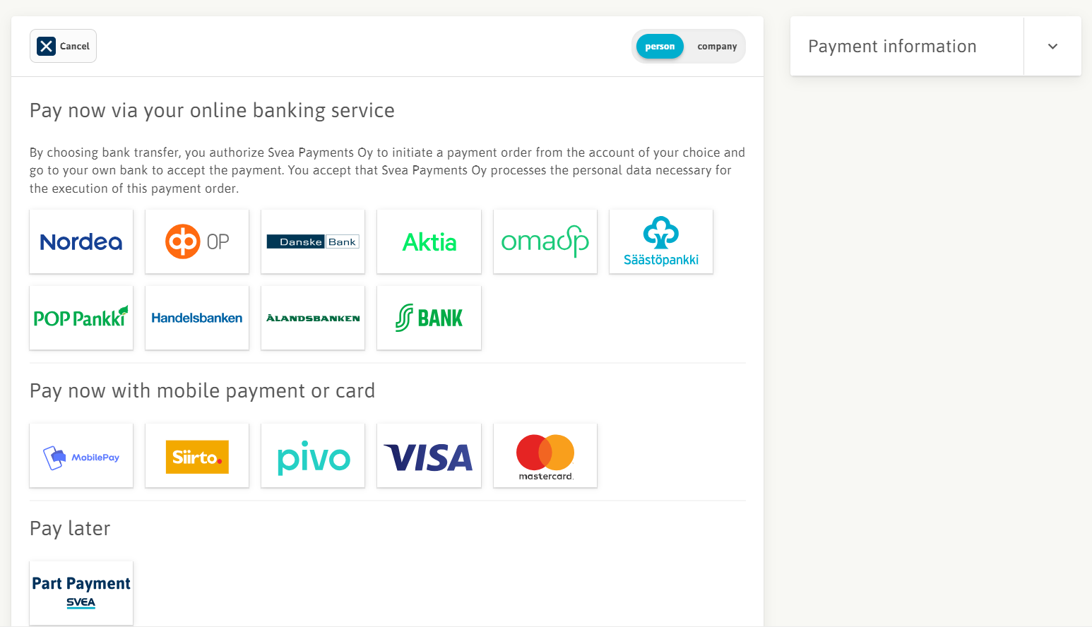

## Svea Payments Configuration

The payment module configuration page is located on the left menu of *Stores / Configuration / Svea Payments*

Description of configuration fields

|  |  |
| --- | --- |
| Seller ID | Use your seller ID provided by Svea Payments. Value is case-sensitive.  Please note that this key must not be shared with any person, since it allows many operations to be done in your Svea Payments account.  You get your production credentials by contacting Svea sales or for testing environment, see [Svea Payments API / TESTING](https://sveapayments.atlassian.net/wiki/spaces/DOCS/pages/1657014153/TESTING) |
| Secret key | The secret key of your credentials. |
| Secret key version | Secret key version specifies the exact secret key of your credentials. Starts from 001. |
| Endpoint | Select the correct environment based on your credentials. |
|  |  |
| Scheduled payment status check | When enabled, scheduled job requests pending payment statuses from the backend system. You can see the schedule below in Status Check Schedule field.  Disable this only if you are using callback option. |
| Manual payment status check | Triggers manual payment status check. This is like scheduled payment status check, but you can manually check pending payments for past 1 hour or 1 week time span. |
| Delivery mode | If you want to send tracking codes to Svea, you can enable this feature. Delivery information is sent automatically on shipment creation, shipment track addition and shipment track removal when enabled.  Real = the real tracking codes are sent to Svea for *All* or *Specific* payment methods, that can be defined at *Payment Methods for which Delivery info sent to Svea*  Custom = You can specify a custom delivery method that you want to send to Svea. The method is defined at *Custom delivery method* (options: Own delivery / Service / Electronic delivery / Untraceable letter). You can choose to send the codes for Allor *Specific* payment methods, that can be defined at *Payment Methods for which Delivery info sent to Svea.* |
| Delayed capture | Normally, all payments are marked as captured when payments are confirmed by Svea. When a payment method is marked as delayed capture payment method, the payment confirmation will not result into the payment be marked as captured. When using Svea payment methods supporting delayed capture (i.e., shipment notices), those methods can be specified here. These methods must be verified together with Svea Payments. |
|  |  |
| *New order status*  **(removed in 1.0.19)** | *Default status for orders when customer has checked out, but payment is still pending.*  **Removed as setting no longer has any effect and in previous versions would break manual status query if changed.** |
| Paid order status | Default status for orders when payment is confirmed. |
| Restore shopping cart on Cancel/Error | If this setting is on, the shopping cart is restored in case on cancel and/or error return from Svea. If this setting is disabled, the shopping cart will be emptied in case of error and/or cancel return. |
| Cancel orders on cancelled payment or error  **(new in 1.0.19)** | Sets if orders should be canceled when the user returns from Svea Payments having canceled payment or encountered an error. The recommended setting is the default **Yes** as that releases the inventory held by the order. Setting this to No can lead to running out of stock so it should only be used on virtual products or if store is not tracking inventory.  Note: Even if setting is set to No Magento will automatically cancel orders in Payment Pending status after the Order Lifetime set in Sales settings expires. |
| Enable refunds after settlement | Enables the refunds after the payment is settled with Svea Bank. When enabled, the admin page show bank account information for refunding the payment to Svea. |
|  |  |

## Svea Part Payment Calculator

The Svea Part Payment Calculator configuration page is located on the left menu of *Stores / Configuration / Svea Payments / Svea Part Payment Calculator*

Part Payment Calculator is a widget that can be used in stores that offer Svea Part Payment as a payment method.

For the configuration of the Part Payment Calculator, you need your Svea Extranet credentials.

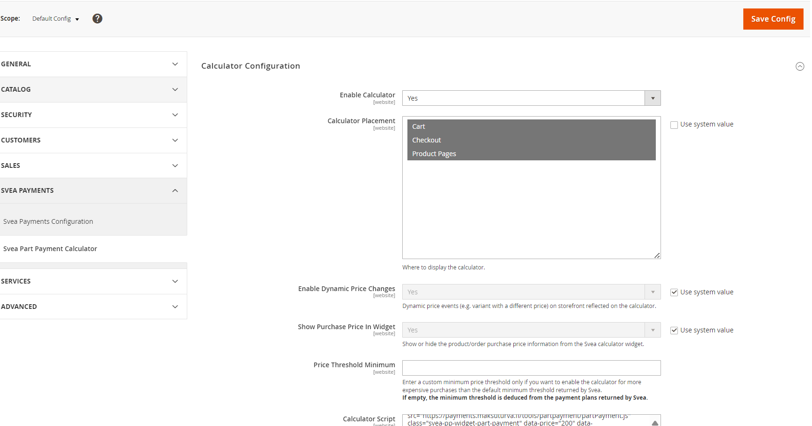

Enable part payment calculator and choose the location where you want the calculator to be displayed for the buyer.

Enable dynamic price changes If enabled, the calculator will update the prices and payment plans dynamically when size / color is changed, and the change affects the product price

Show purchase price in widget If this is enabled, the part payment calculator will show one additional information field containing the purchase price of the product(s) in question. If set as “No” the purchase price field will not be shown in the calculator. Purchase price = price of the product.

Price Threshold Minimum If you want to display the part payment calculator only for more expensive purchases than the default minimum threshold determined by Svea, you can enter the new value here. Use numeric value (i.e., 75).

If the field is left empty, the minimum default value from Svea is used (normally 50 € but can also be customized with Svea).

Calculator Script Log in to Svea Extranet / Materials and create a script for part payment calculator. Paste the script in this field. It is recommended not to modify the script.

Part payment calculator displayed in shopping cart:

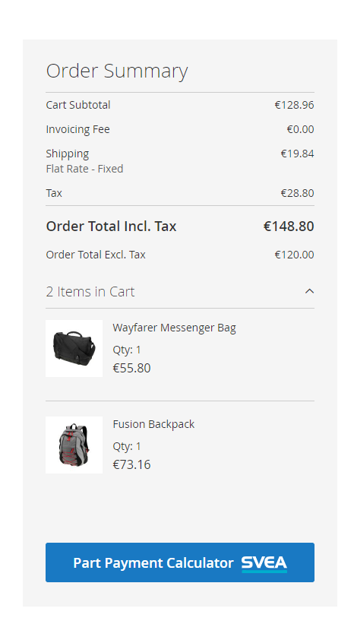

Example of calculator with Purchase price enabled:

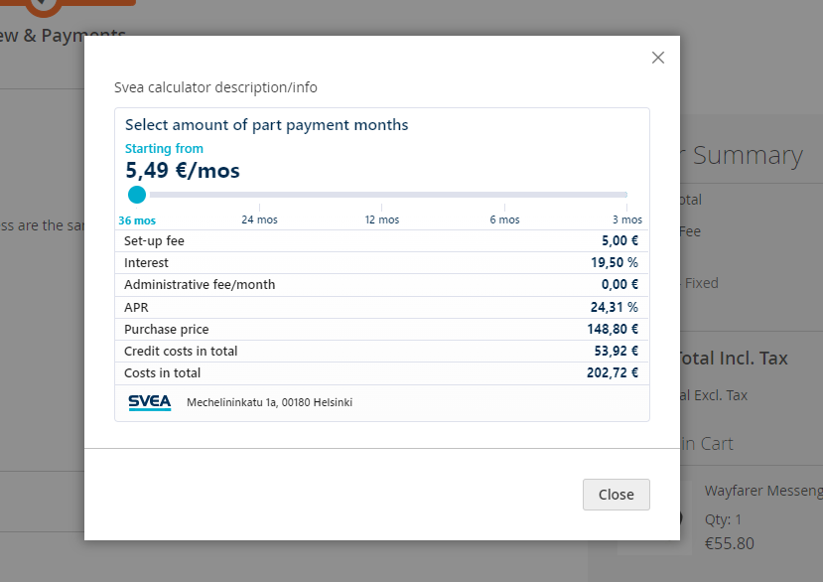

## Additional features

### Payment Fees

The payment module has support for defining invoicing fees for each sub method under each payment method, including Collated payment method. For example, with "10;FI01=5;FI06=7.5" the fee in quote gets resolved based on the selected method in the following way:

* FI01 gets a fee of 5

* FI06 gets a fee of 7.5

* Other methods in that group get a fee of 10

### Delayed capture

In case part payment or invoice payment methods are used, this can be used to specify delayed capture for these payment methods. Normally, all payments are marked as captured when payments are confirmed by Svea. When a payment method is marked as delayed capture payment method, the payment confirmation will not result into the payment be marked as captured. That is, to capture these, creation of invoice with capture case set to "online" is required.

This is usually used if capture should be done only after shipping the goods to the customer. In case of ERP integration, the integration is responsible of creating the invoice and thus triggering the capture.

Please note that only few methods support delayed capture, these need to be verified from Svea Payments.

### Automatic status query

If enabled, this will activate a cronjob that queries `Pending` payments from Svea Payments API. This kind of order might occasionally happen, if after successful payment customer does not return to the web shop, but the payment transaction was successful.

Job is run every 30 minutes, and the status is queried pending orders not older than one week. If you need to check older order statuses, use the manual query on the admin page.

To check that automatic status query is working, see log file for following items. The job is run every 30 minutes, so you need wait a while after activation.

If you are not getting the log items above, check section `Cron Jobs`.

# Order administration

At checkout, Svea payment module creates Magento order and invoice.

The payment module automatically verifies payments from Svea Payment services and displays corresponding status on the order page. The order admin page includes manual Svea payment status query button.

All transaction information and status changes can be found at the bottom of the order page.

## Refunding order

To refund order fully or partially, select Order / Invoices and select Invoice / View to be refunded.

Select the Credit Memo at the upper top menu when an invoice is opened.

To initiate a refund process, select the products and adjust the totals as necessary.

If the refund amount is *equal to the invoiced amount*, the order will be fully refunded, and the order will be canceled.

However, if the refund amount is *less than the invoiced amount*, a partial refund is created without canceling the order.

For an online refund, click on the "Refund" button available at the bottom right corner.

# Logging

The payment module logs can be found in the Magento log directory (for example /var/www/html/var/log).

* svea_payment_error.log
* svea_payment_debug.log
* svea_payment_audit.log

# Resolving issues and support

If you happen to come across a non-critical issue or have any suggestions for improvement, we kindly request you to submit a GitHub issue.

If you require assistance with activating the payment module or resolving critical issues, please don't hesitate to contact:

* For General support, please contact [info.payments@svea.fi](mailto:info.payments@svea.fi)
* For Technical support, please contact [support.payments@svea.fi](mailto:support.payments@svea.fi)

We are always here to help you out.

## Common problems and solutions

* If you get `No payment methods available` on payment page, you might check the sellerid, secret key and endpoint once more.